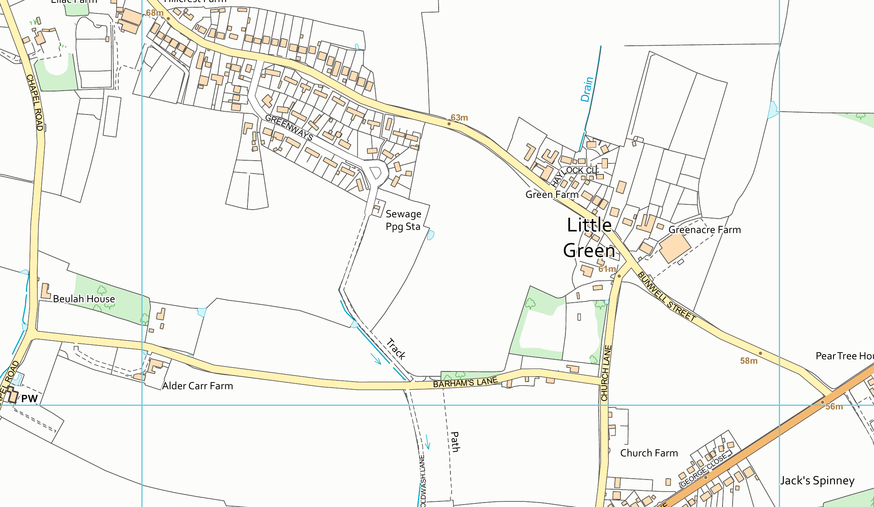









© Crown copyright and database rights 2024 Ordnance Survey (AC0000851941). FOR EDUCATIONAL USE ONLY.


Scale 1:5000

Sarah Spooner University of East
0 50 100 150 200 250 300 350 400 450 500 m

Projection: British National Grid

Anglia 05 March 2024 14:56
Digimap

